Database Management System
Course Project Report
On
SPORTS STORE SYSTEM

Submitted in partial fulfilment of the requirement of Bachelor of Technology (S.Y) in
COMPUTER ENGINEERING

Submitted by
ALBERT ANTONY-1023102
AARON COUTINHO-1023122
DERIL DAVIS-1023124
OMKAR DESAI-1023125



Department of Computer Engineering
Fr. Conceicao Rodrigues Institute of Technology, Sector 9A,
Vashi, Navi Mumbai - 400703

(An Autonomous Institute & Permanently Affiliated to University of Mumbai) 2024-2025

Problem Statement for Sports Store System:

In today’s digital age, customers expect a convenient platform to explore and purchase sports products online. A sports store must offer a user-friendly shopping experience that enables customers to browse a variety of products, add items to their cart, and place orders seamlessly, while also providing order tracking and personalized service.

The Sports Store System will focus on:
- Product Browsing: Customers can easily search and filter a wide range of sports items, including fitness gear, team equipment, and accessories.
- Cart and Order Management: Users can add products to their cart, proceed to checkout, and receive instant order confirmations.
- Secure Account Management: Customers need to register, log in securely, and access their order history.
- Payment and Security: Provide secure payment options to ensure safe transactions.
- Performance and Reliability: Ensure quick searches and smooth transactions, even with a growing product catalog.

This system aims to deliver a fast, secure, and enjoyable shopping experience, making it easy for customers to explore and purchase sports products online.

OBJECTIVES:
1. Product Management:
Provide a wide range of sports products with easy search and filtering options.
2. User-Friendly Shopping:
Enable seamless cart management, checkout, and order placement.
3. Secure User Management:
Ensure safe registration, login, and access to profiles and order history.
4. Payment Security:
Provide secure payment gateways for safe transactions
5. Scalability:
Ensure the system performs efficiently as the product range and user base
grow.

- DATABASE DESIGN (ER DIAGRAM):
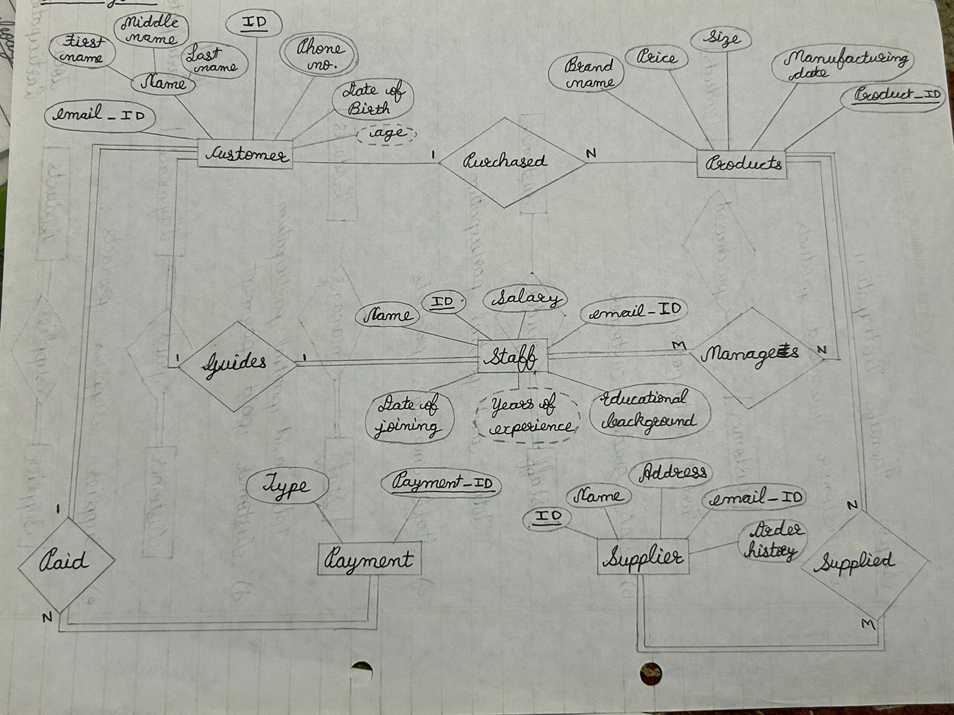

- JAVA INTERFACE
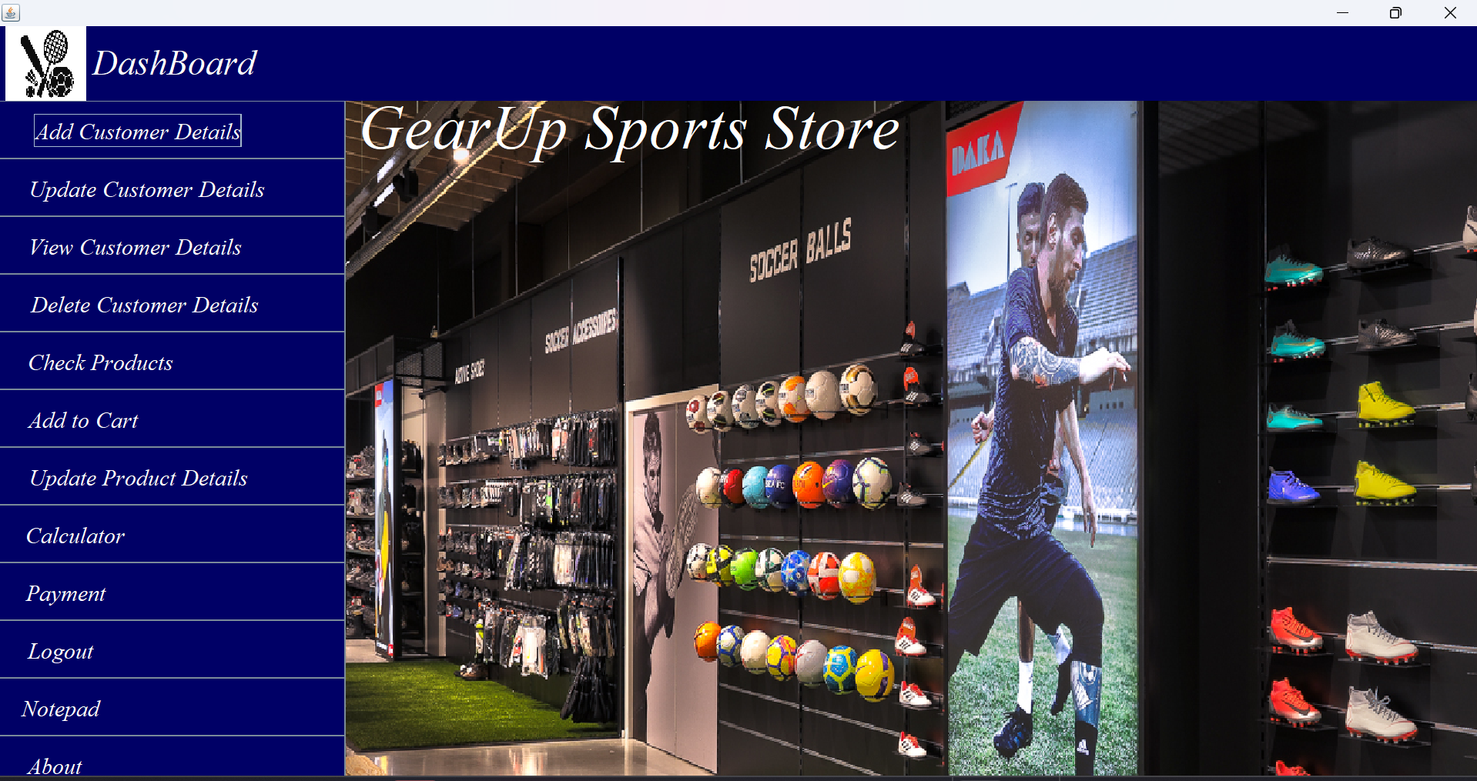
  - JAVA GUI

package sports.store.management.system;
import javax.swing.*;
import java.awt.*;
import java.awt.event.*;
public class Dashboard extends JFrame implements ActionListener {
String customerid;
JButton addcustomerDetails, viewcustomerDetails, updatecustomerDetails, checkProducts, addtocartProducts, payment, calculator, logout, notepad, about, deletecustomerDetails, updateproductdetails;
Dashboard(String customerid) {
this.customerid = customerid;
setBounds(0, 0, 1600, 1000);
setExtendedState(JFrame.MAXIMIZED_BOTH);
setLayout(null);
JPanel p1 = new JPanel();
p1.setLayout(null);
p1.setBackground(new Color(0, 0, 102));
p1.setBounds(0, 0, 1600, 65);
add(p1);
ImageIcon i1 = new ImageIcon(ClassLoader.getSystemResource("Images/Dashboard icon.jpg"));
Image i2 = i1.getImage().getScaledInstance(70, 70, Image.SCALE_DEFAULT);
ImageIcon i3 = new ImageIcon(i2);
JLabel icon = new JLabel(i3);
icon.setBounds(5, 0, 70, 70);
p1.add(icon);
JLabel heading = new JLabel("DashBoard");
heading.setBounds(80, 10, 300, 40);
heading.setForeground(Color.WHITE);
heading.setFont(new Font("serif", Font.ITALIC, 30));
p1.add(heading);
JPanel p2 = new JPanel();
p2.setLayout(null);
p2.setBackground(new Color(0, 0, 102));
p2.setBounds(0, 65, 300, 900); add(p2);
addcustomerDetails = new JButton("Add Customer Details");
addcustomerDetails.setBounds(0, 0, 300, 50);
addcustomerDetails.setBackground(new Color(0, 0, 102));
addcustomerDetails.setForeground(Color.WHITE);
addcustomerDetails.setFont(new Font("serif", Font.ITALIC, 20));
addcustomerDetails.setMargin(new Insets(0, 0, 0, 60)); // top,left,bottom,right
addcustomerDetails.addActionListener(this);
p2.add(addcustomerDetails);
updatecustomerDetails = new JButton("Update Customer Details");
updatecustomerDetails.setBounds(0, 50, 300, 50);
updatecustomerDetails.setBackground(new Color(0, 0, 102));
updatecustomerDetails.setForeground(Color.WHITE);
updatecustomerDetails.setFont(new Font("serif", Font.ITALIC, 20));
updatecustomerDetails.setMargin(new Insets(0, 0, 0, 45)); // top,left,bottom,right
updatecustomerDetails.addActionListener(this);
p2.add(updatecustomerDetails);
viewcustomerDetails = new JButton("View Customer Details");
viewcustomerDetails.setBounds(0, 100, 300, 50);
viewcustomerDetails.setBackground(new Color(0, 0, 102));
viewcustomerDetails.setForeground(Color.WHITE);
viewcustomerDetails.setFont(new Font("serif", Font.ITALIC, 20));
viewcustomerDetails.setMargin(new Insets(0, 0, 0, 65)); // top,left,bottom,right
viewcustomerDetails.addActionListener(this);
p2.add(viewcustomerDetails);
deletecustomerDetails = new JButton("Delete Customer Details");
deletecustomerDetails.setBounds(0, 150, 300, 50);
deletecustomerDetails.setBackground(new Color(0, 0, 102));
deletecustomerDetails.setForeground(Color.WHITE);
deletecustomerDetails.setFont(new Font("serif", Font.ITALIC, 20));
deletecustomerDetails.setMargin(new Insets(0, 0, 0, 50)); // top,left,bottom,right
deletecustomerDetails.addActionListener(this);
p2.add(deletecustomerDetails);

checkProducts = new JButton("Check Products");
checkProducts.setBounds(0, 200, 300, 50);
checkProducts.setBackground(new Color(0, 0, 102));
checkProducts.setForeground(Color.WHITE);
checkProducts.setFont(new Font("serif", Font.ITALIC, 20));
checkProducts.setMargin(new Insets(0, 0, 0, 125)); // top,left,bottom,right
checkProducts.addActionListener(this);
p2.add(checkProducts);
addtocartProducts = new JButton("Add to Cart");
addtocartProducts.setBounds(0, 250, 300, 50);
addtocartProducts.setBackground(new Color(0, 0, 102));
addtocartProducts.setForeground(Color.WHITE);
addtocartProducts.setFont(new Font("serif", Font.ITALIC, 20));
addtocartProducts.setMargin(new Insets(0, 0, 0, 155)); // top,left,bottom,right
addtocartProducts.addActionListener(this);
p2.add(addtocartProducts);
updateproductdetails = new JButton("Update Product Details");
updateproductdetails.setBounds(0, 300, 300, 50);
updateproductdetails.setBackground(new Color(0, 0, 102));
updateproductdetails.setForeground(Color.WHITE);
updateproductdetails.setFont(new Font("serif", Font.ITALIC, 20));
updateproductdetails.setMargin(new Insets(0, 0, 0, 60)); // top,left,bottom,right
updateproductdetails.addActionListener(this);
p2.add(updateproductdetails);
calculator = new JButton("Calculator");
calculator.setBounds(0, 350, 300, 50);
calculator.setBackground(new Color(0, 0, 102));
calculator.setForeground(Color.WHITE);
calculator.setFont(new Font("serif", Font.ITALIC, 20));
calculator.setMargin(new Insets(0, 0, 0, 170)); // top,left,bottom,right
calculator.addActionListener(this);
p2.add(calculator);
payment = new JButton("Payment");
payment.setBounds(0, 400, 300, 50);
payment.setBackground(new Color(0, 0, 102));
payment.setForeground(Color.WHITE);
payment.setFont(new Font("serif", Font.ITALIC, 20));
payment.setMargin(new Insets(0, 0, 0, 185)); // top,left,bottom,right
payment.addActionListener(this);
p2.add(payment);
logout = new JButton("Logout");
logout.setBounds(0, 450, 300, 50);
logout.setBackground(new Color(0, 0, 102));
logout.setForeground(Color.WHITE);
logout.setFont(new Font("serif", Font.ITALIC, 20));
logout.setMargin(new Insets(0, 0, 0, 195)); // top,left,bottom,right
logout.addActionListener(this);
p2.add(logout);
notepad = new JButton("Notepad");
notepad.setBounds(0, 500, 300, 50);
notepad.setBackground(new Color(0, 0, 102));
notepad.setForeground(Color.WHITE);
notepad.setFont(new Font("serif", Font.ITALIC, 20));
notepad.setMargin(new Insets(0, 0, 0, 195)); // top,left,bottom,right
notepad.addActionListener(this);
p2.add(notepad);
about = new JButton("About");
about.setBounds(0, 550, 300, 50);
about.setBackground(new Color(0, 0, 102));
about.setForeground(Color.WHITE);
about.setFont(new Font("serif", Font.ITALIC, 20));
about.setMargin(new Insets(0, 0, 0, 205)); // top,left,bottom,right
about.addActionListener(this);
p2.add(about);
ImageIcon i4 = new ImageIcon(ClassLoader.getSystemResource("Images/Dashboard.jpg"));
Image i5 = i4.getImage().getScaledInstance(1650, 1000, Image.SCALE_DEFAULT);
ImageIcon i6 = new ImageIcon(i5);
JLabel image = new JLabel(i6);
image.setBounds(0, 0, 1650, 1000);
add(image);

JLabel text = new JLabel("GearUp Sports Store");
text.setBounds(310, 50, 1200, 70);
text.setForeground(Color.WHITE);
text.setFont(new Font("serif", Font.ITALIC, 55));
image.add(text);
setVisible(true);
}
public void actionPerformed(ActionEvent ae) {
if (ae.getSource() == addcustomerDetails) {
new Addcustomer(customerid);
} else if (ae.getSource() == viewcustomerDetails) {
new ViewCustomer(customerid);
} else if (ae.getSource() == updatecustomerDetails) {
new UpdateCustomer(customerid);
} else if (ae.getSource() == checkProducts) {
new CheckProducts();
} else if (ae.getSource() == addtocartProducts) {
new AddtoCart(customerid);
} else if (ae.getSource() == payment) {
new Payment();
} else if (ae.getSource() == logout) {
setVisible(false);
System.exit(0);
} else if (ae.getSource() == calculator) {
try {
Runtime.getRuntime().exec("calc.exe");
} catch (Exception e) {
e.printStackTrace();
}
} else if (ae.getSource() == notepad) {
try {
Runtime.getRuntime().exec("notepad.exe");
} catch (Exception e) {
e.printStackTrace();
}
} else if (ae.getSource() == about) {
new About();
} else if (ae.getSource() == deletecustomerDetails) {
new DeleteDetails(customerid);
} else if (ae.getSource() == updateproductdetails) {
new UpdateProductDetails(customerid);
}
}
public static void main(String[] args) {
new Dashboard("Omkar123");
}
}
  - JAVA CONNECTIVITY:
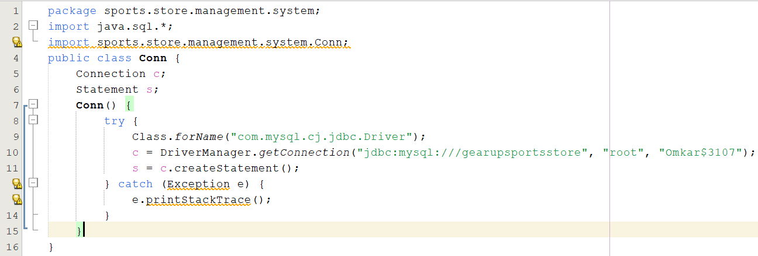
- SQL CODE:
CREATE DATABASE gearupsportsstore;
SHOW DATABASES;
USE gearupsportsstore;
CREATE TABLE customer (
customerID VARCHAR(30) PRIMARY KEY,
name VARCHAR(30),
password VARCHAR(40),
question VARCHAR(40),
answer VARCHAR(40)
);
SHOW TABLES;
SELECT * FROM customer;
CREATE TABLE customer1 (
CustomerID VARCHAR(30),
Name VARCHAR(30),
ID VARCHAR(20),
EmailID VARCHAR(30),
Phoneno VARCHAR(15),
Address VARCHAR(50),
CONSTRAINT fk_customer FOREIGN KEY (CustomerID) REFERENCES customer(customerID) ON DELETE CASCADE
);
SELECT * FROM customer1;
CREATE TABLE products1234567 (
customerID VARCHAR(50),
product_type VARCHAR(50),
brand VARCHAR(50),
quantity VARCHAR(50),
warranty VARCHAR(50),
total_price VARCHAR(50),
purchase_time TIMESTAMP DEFAULT CURRENT_TIMESTAMP,
CONSTRAINT fk_products_customer FOREIGN KEY (customerID) REFERENCES customer(customerID) ON DELETE CASCADE
);
SELECT * FROM products1234567;
CREATE TABLE subproduct12345 (
customerID VARCHAR(50),
teamsports_products VARCHAR(50),
fitness_products VARCHAR(50),
trekking_products VARCHAR(50),
cycling_products VARCHAR(50),
indoorsports_products VARCHAR(50),
accessories VARCHAR(50),
shoes VARCHAR(50),
jerseys VARCHAR(50),
CONSTRAINT fk_subproducts_customer FOREIGN KEY (customerID) REFERENCES customer(customerID) ON DELETE CASCADE
);
SELECT
c.customerID,
c.name AS customer_name,
c1.ID,
c1.EmailID,
c1.Phoneno,
c1.Address
FROM
customer c
JOIN
customer1 c1
ON
c.customerID = c1.CustomerID;
SELECT
p.customerID,
p.product_type,
p.brand,
p.quantity,
p.warranty,
p.total_price,
sp.teamsports_products,
sp.fitness_products,
sp.trekking_products,
sp.cycling_products,
FROM
products1234567 p
JOIN
subproduct12345 sp
ON
p.customerID = sp.customerID;
SELECT * FROM subproduct12345;
SELECT * FROM products1234567
WHERE customerID = 'Aaron123'
ORDER BY purchase_time DESC
LIMIT 1;
CREATE TABLE customer_audit (
auditID INT AUTO_INCREMENT PRIMARY KEY,
customerID VARCHAR(30),
action VARCHAR(50),
action_time TIMESTAMP DEFAULT CURRENT_TIMESTAMP
);
DELIMITER //
CREATE TRIGGER after_customer_insert
AFTER INSERT ON customer
FOR EACH ROW
BEGIN
INSERT INTO customer_audit (customerID, action) VALUES (NEW.customerID, 'INSERT');
END;//
DELIMITER ;
DELIMITER //
CREATE TRIGGER after_customer_update
AFTER UPDATE ON customer
FOR EACH ROW
BEGIN
INSERT INTO customer_audit (customerID, action) VALUES (NEW.customerID, 'UPDATE');
END;//
DELIMITER ;
DELIMITER //
CREATE TRIGGER after_customer_delete
AFTER DELETE ON customer
FOR EACH ROW
BEGIN
INSERT INTO customer_audit (customerID, action) VALUES (OLD.customerID, 'DELETE');
END;//
DELIMITER ;
CREATE TABLE product_audit (
auditID INT AUTO_INCREMENT PRIMARY KEY,
customerID VARCHAR(50),
product_type VARCHAR(50),
action VARCHAR(50),
action_time TIMESTAMP DEFAULT CURRENT_TIMESTAMP
);
DELIMITER //
CREATE TRIGGER after_product_insert
AFTER INSERT ON products1234567
FOR EACH ROW
BEGIN
INSERT INTO product_audit (customerID, product_type, action) VALUES (NEW.customerID, NEW.product_type, 'INSERT');
END;//
DELIMITER ;
DELIMITER //
CREATE TRIGGER after_product_update
AFTER UPDATE ON products1234567
FOR EACH ROW
BEGIN
INSERT INTO product_audit (customerID, product_type, action) VALUES (NEW.customerID, NEW.product_type, 'UPDATE');
END;//
DELIMITER ;
DELIMITER //
CREATE TRIGGER after_product_delete
AFTER DELETE ON products1234567
FOR EACH ROW
BEGIN
INSERT INTO product_audit (customerID, product_type, action) VALUES (OLD.customerID, OLD.product_type, 'DELETE');
END;//
DELIMITER ;

